**Project -**

**Revenue Insights**

**for a Hotel Brand in the Hospitality Domain**

**Content**

* Problem Statement.
* Mock-up Dashboard.
* KPI for Hotel Chain Business.
* Tools
* Key steps for Project Development

1. Data Exploration and Data Cleaning.
2. Data Modelling.
3. Creating DAX measures and columns.
4. Data Visualisation.

* Final Dashboard (Screenshots)
* Derived Key Insights.

**Problem Statement:**

**AtliQ** Grands owns multiple five-star hotels across India. They have been in the hospitality industry for the past 20 years. Due to strategic moves from other competitors and ineffective decision-making in management, AtliQ Grands is losing its market share and revenue in the luxury/business hotels category. As a strategic move, the managing director of AtliQ Grands wanted to incorporate “Business and Data Intelligence” to regain their market share and revenue. However, they do not have an in-house data analytics team to provide them with these insights.  
  
Their revenue management team had decided to hire a 3rd party service provider to provide them with insights from their historical data.

**Task:**    
  
You are a data analyst who has been provided with sample data and a mock-up dashboard to work on the following task. You can download all relevant documents from the download section.

1. Create the metrics according to the metric list.
2. Create a dashboard according to the mock-up provided by stakeholders.
3. Create relevant insights that are not provided in the metric list/mock-up dashboard.

**Website link** :

https://codebasics.io/challenge/codebasics-resume-project-challenge

**Mock-up Dashboard:**

Below dummy dashboard below is provided for reference and guidance. We can understand and pick some of the expected visuals from it.

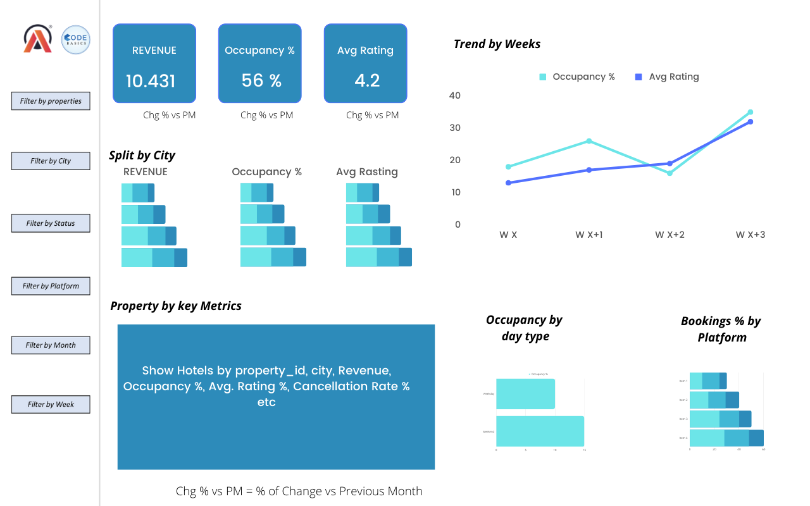

**Observed Visuals to be included:**

* Important KPIs.
* Filters by Week, Month, City, Booking Channels/Platforms, and Room Class.
* Weekend vs Weekday Performance.
* Table contains the list of hotels/properties.
* Trend line graph which shows monthly or weekly trend going on of a performance parameter.
* 6. Important parameters are split by significant categorical data elements.
* Example. Revenue is split across the city; Booking is split across different booking platforms.

**KPI for Hotel Chain Business:**

Key Performance Indicators ie. KPIs are the measures of a business domain, that help us to evaluate and analyse business health. By tracking them across different significant categories of data or over a period of time we can easily conclude how the business is performing in the market.

In the project challenge, we’ve given the scenario of a hotel chain business which belongs to the Hospitality domain. It’s the business where customers own a hotel room and pay for the services & and included allowances, for the period.

Important KPIs –

**1. Revenue:**

The amount of money generated by a business through its sales done over the considered period of time.

**2.** **RevPAR:**

Stands for ‘Revenue Per Available Room’.

Basically, it’s the average revenue per available room to sell.

RevPAR = (Total Revenue) / (Total available rooms to sell).

**3**. **Occupancy Rate:**

How many rooms are occupied/sold out of the total available room to sell?

Occupancy % = (Rooms sold) / (Total rooms available for sale) * 100

**4.** **ADR:**

Stands for Average Daily Rate.

Basically. It’s average revenue per sold room.

ADR = (Total Revenue) / (Total number of rooms sold).

**5. Cancellation rate:**

It’s the number of rooms cancelled by the total number of rooms booked.

Cancellation % =

(Number of rooms cancelled) / (Number of rooms booked) * 100

**6. SRN or DSRN:**

Stands for Daily Saleable Room Nights.

It means a number of rooms which are saleable for a night (whole day).

**7. BRN or DBRN:**

Stands for Daily Booked Room Nights.

It means a number of rooms which are booked for a night (whole day).

**8. URN or DURN:**

Stands for Daily Utilized Room Nights.

It means a number of rooms which are taken/utilized for a night (whole day).

**9. Realisation rate:**

It’s basically a number of utilized/taken rooms by a number of booked rooms for a night (whole day).

Realisation % = (URN / BRN) * 100

**Tools:**

* Microsoft Power BI
* Microsoft Excel

**Key steps for Project Development:**

For this project, we are using-

1. Microsoft Power BI tool.
2. Microsoft Excel tool.

Primarily Power BI tool itself is used for 95% of project development work and MS Excel is used for data exploration and data validation purposes.

Key steps for project development are

1. Data Exploration and Data Cleaning.
2. Data Modelling.
3. Creating DAX measures and columns.
4. Data Visualisation.

**A). Data Exploration and Data Cleaning:**

This is the first step towards our project development. Here we’ll understand & and explore the raw data we have collected/provided.

We have five Excel files which are-

1. “dim_date.csv”

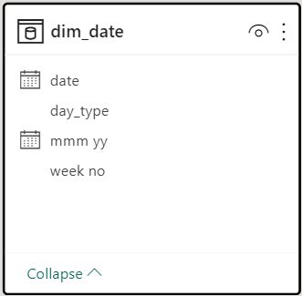

This table shows that the data is for three months, that is June, July, and May. This means from week 19 to week 32.

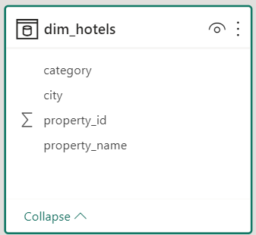2. “dim_hotels.csv”

The ‘property_name’ column consists of distinct values as below-

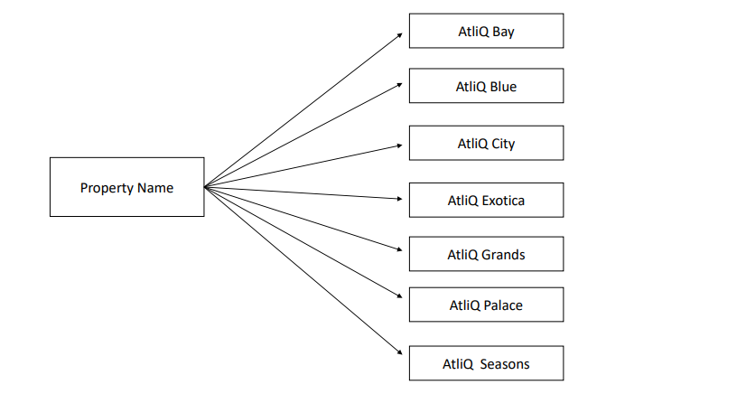

The ‘City’ column consists of distinct values as below-

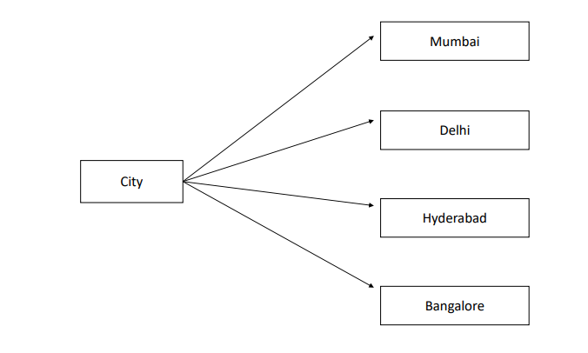

The ‘category’ column consists of distinct values as below-

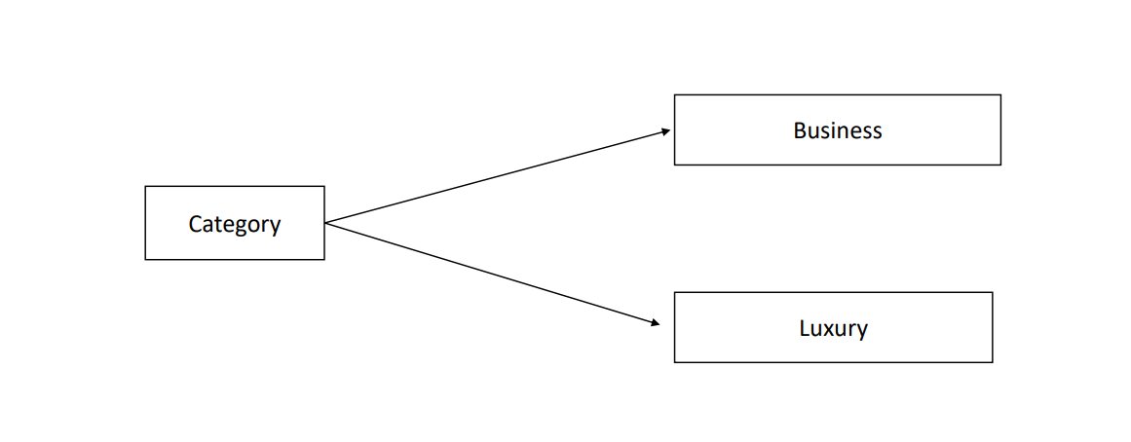

3. “dim_roooms.csv”

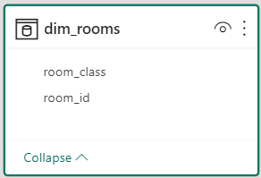

The ‘room_class’ column consists of distinct values as below-

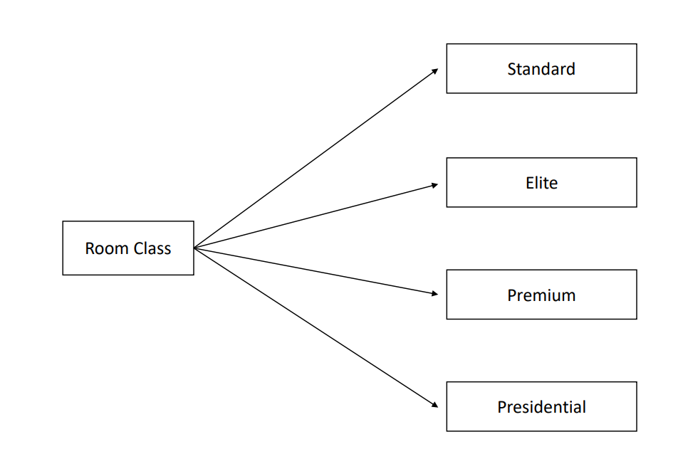

4. “fact_bookings.csv”

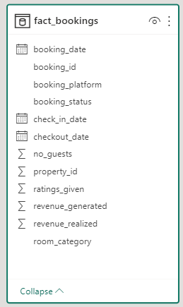

The ‘booking_platform’ column consists of distinct values as below-

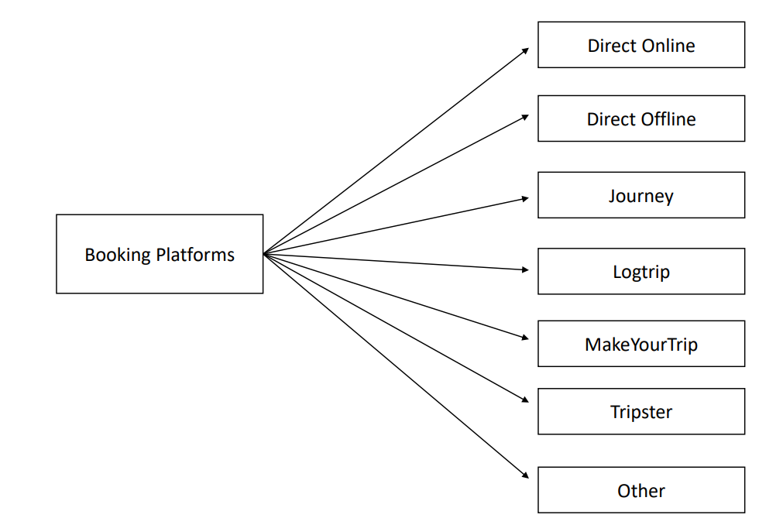

5. “fact_aggregated_bookings.csv”

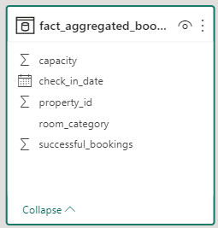

This table shows the aggregated booking values like-

Total successful bookings, total capacity for different hotels/properties by different classes of rooms, for individual dates date of booking.

In this ‘data cleaning and exploration’ data is cleaned by implementing multiple data transformation steps like

* Validating data type of columns
* Renaming columns
* Adding new columns by extracting segments of data from another column.

, Etc

These steps are purpose-driven, which means in what shape do we want our data, on that basis one defines a set of data transformation steps. Hence, the selection of these data-cleaning procedure steps is subjective from developer to developer.

**B). Data Modelling:**

In recent steps, we’ve toned get shaped our data. However, the tables are still separate objects which have no connection or relationship between them.

Here Data modelling comes into the picture, where we create relationships between the tables. Due to establishing relationships among data in the tabular form, it can be viewed as a single model.

In data modelling, tables are broadly categorised into two types -

a. Fact table

b. Dimension table

To create a relationship, we link the primary key of the dimension/ lookup table to the foreign key of the fact table. Hence, there will be a parent-child relationship established, so every data from the tables will be interlinked and share the context flow across the model.

**Data Model created:**

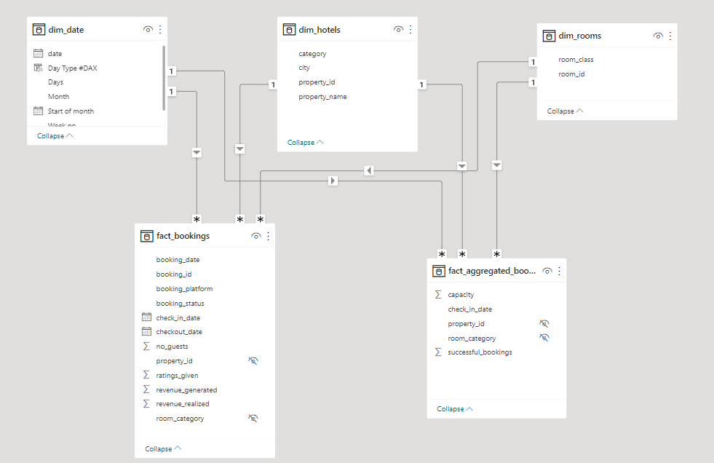

**C). Creating DAX measure:**

In this step we have created calculated measures using DAX, these measures are nothing but the performance indicators which are crucial for evaluating business performance.

**List of Calculated measures:**

**1. Revenue**

Revenue = SUM( fact_bookings[revenue_realized] )

**2. Total Bookings**

Total Bookings = COUNT(fact_bookings[booking_id])

**3. Total Capacity**

Total Capacity = SUM(fact_aggregated_bookings[capacity])

**4. Total Succesful Bookings**

Total Succesful Bookings = SUM(fact_aggregated_bookings[successful_bookings])

**5. Occupancy %**

Occupancy % = DIVIDE([Total Succesful Bookings],[Total Capacity],0)

**6. Average Rating**

Average Rating = AVERAGE(fact_bookings[ratings_given])

**7. No of days**

No of days = DATEDIFF(MIN(dim_date[date]),MAX(dim_date[date]),DAY) +1

**8. Total cancelled bookings**

Total cancelled bookings = CALCULATE([Total Bookings],fact_bookings[booking_status]="Cancelled")

**9. Cancellation %**

Cancellation % = DIVIDE([Total cancelled bookings],[Total Bookings])

**10. Total Checked Out**

Total Checked Out = CALCULATE([Total Bookings],fact_bookings[booking_status]="Checked Out")

**11. Total no-show bookings**

Total no show bookings = CALCULATE([Total Bookings],fact_bookings[booking_status]="No Show")

**12. No Show rate %**

No Show rate % = DIVIDE([Total no show bookings],[Total Bookings])

**13. Booking % by Platform**

Booking % by Platform = DIVIDE([Total Bookings],  
 CALCULATE([Total Bookings],   
 ALL(fact_bookings[booking_platform])  
 ))*100

14. Booking % by Room class

Booking % by Room class = DIVIDE([Total Bookings],  
 CALCULATE([Total Bookings],   
 ALL(dim_rooms[room_class])  
 ))*100

**15. ADR**

ADR = DIVIDE( [Revenue], [Total Bookings],0)

**16. Realisation %**

Realisation % = 1- ([Cancellation %]+[No Show rate %])

**17. RevPAR**

RevPAR = DIVIDE([Revenue],[Total Capacity])

**18. DBRN**

DBRN = DIVIDE([Total Bookings], [No of days])

**19. DSRN**

DSRN = DIVIDE([Total Capacity], [No of days])

**20. DURN**

DURN = DIVIDE([Total Checked Out],[No of days])

**21. Revenue WoW change %**

Revenue WoW change % =   
 Var selv = IF(HASONEFILTER(dim_date[wn]),SELECTEDVALUE(dim_date[wn]),MAX(dim_date[wn]))  
 var revcw = CALCULATE([Revenue],dim_date[wn]= selv)  
 var revpw = CALCULATE([Revenue],FILTER(ALL(dim_date),dim_date[wn]= selv-1))  
  
 return  
  
 DIVIDE(revcw,revpw,0)-1

**22. Occupancy WoW change %**

Occupancy WoW change % =   
 Var selv = IF(HASONEFILTER(dim_date[wn]),SELECTEDVALUE(dim_date[wn]),MAX(dim_date[wn]))  
 var revcw = CALCULATE([Occupancy %],dim_date[wn]= selv)  
 var revpw = CALCULATE([Occupancy %],FILTER(ALL(dim_date),dim_date[wn]= selv-1))  
  
 return  
  
 DIVIDE(revcw,revpw,0)-1

**23. ADR WoW change %**

ADR WoW change % =   
 Var selv = IF(HASONEFILTER(dim_date[wn]),SELECTEDVALUE(dim_date[wn]),MAX(dim_date[wn]))  
 var revcw = CALCULATE([ADR],dim_date[wn]= selv)  
 var revpw = CALCULATE([ADR],FILTER(ALL(dim_date),dim_date[wn]= selv-1))  
  
 return  
  
 DIVIDE(revcw,revpw,0)-1

**24. Revpar WoW change %**

Revpar WoW change % =   
 Var selv = IF(HASONEFILTER(dim_date[wn]),SELECTEDVALUE(dim_date[wn]),MAX(dim_date[wn]))  
 var revcw = CALCULATE([RevPAR],dim_date[wn]= selv)  
 var revpw = CALCULATE([RevPAR],FILTER(ALL(dim_date),dim_date[wn]= selv-1))  
  
 return  
  
 DIVIDE(revcw,revpw,0)-1

**25. Realisation WoW change %**

Realisation WoW change % =   
 Var selv = IF(HASONEFILTER(dim_date[wn]),SELECTEDVALUE(dim_date[wn]),MAX(dim_date[wn]))  
 var revcw = CALCULATE([Realisation %],dim_date[wn]= selv)  
 var revpw = CALCULATE([Realisation %],FILTER(ALL(dim_date),dim_date[wn]= selv-1))  
  
 return  
  
 DIVIDE(revcw,revpw,0)-1

**26. DSRN WoW change %**

DSRN WoW change % =   
Var selv = IF(HASONEFILTER(dim_date[wn]),SELECTEDVALUE(dim_date[wn]),MAX(dim_date[wn]))  
var revcw = CALCULATE([DSRN],dim_date[wn]= selv)  
var revpw = CALCULATE([DSRN],FILTER(ALL(dim_date),dim_date[wn]= selv-1))  
  
return  
  
DIVIDE(revcw,revpw,0)-1

**D). Data Visualisation:**

This is the most significant step where we bring our data live by creating a dynamic and interactive dashboard. For data visualisation, we used the MS Power BI tool.

As we had provided a mock-up dashboard, we have considered it for reference, specifically to choose visual needs to be included.

The dashboard is built with the assumption that the intended end consumers of the dashboard are managerial-level people and stakeholders. Therefore, it contains less low-level details and more conclusion-based data representation.

**Final Dashboard (Screenshots)-**

**Home View**

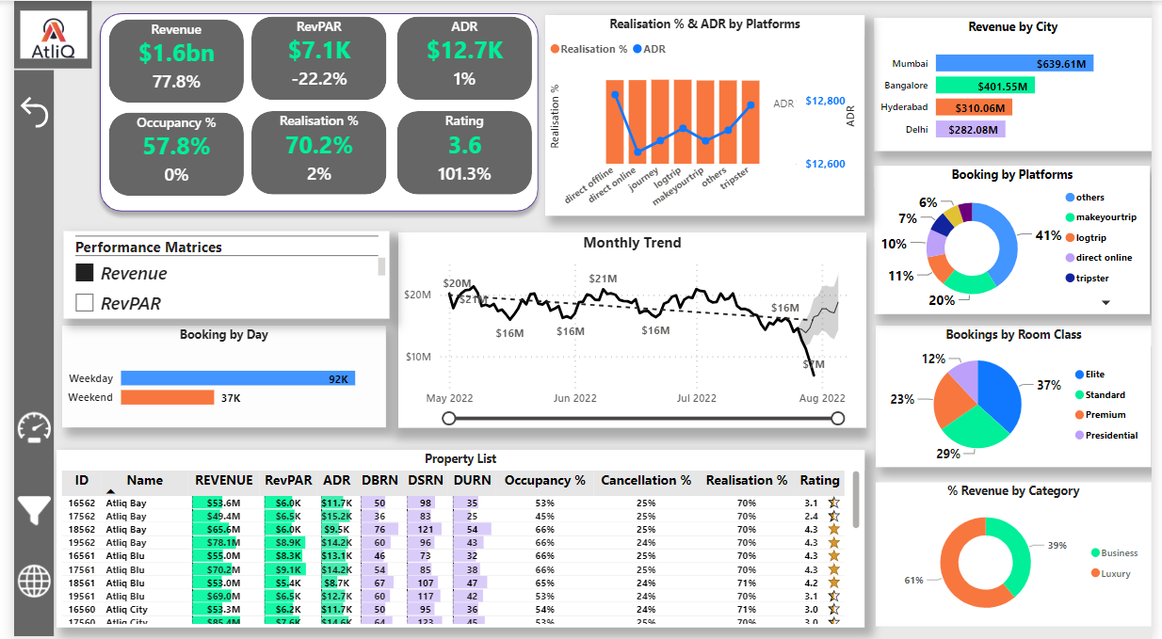

**Booking status View**

By clicking the ‘*View Booking Status’* button

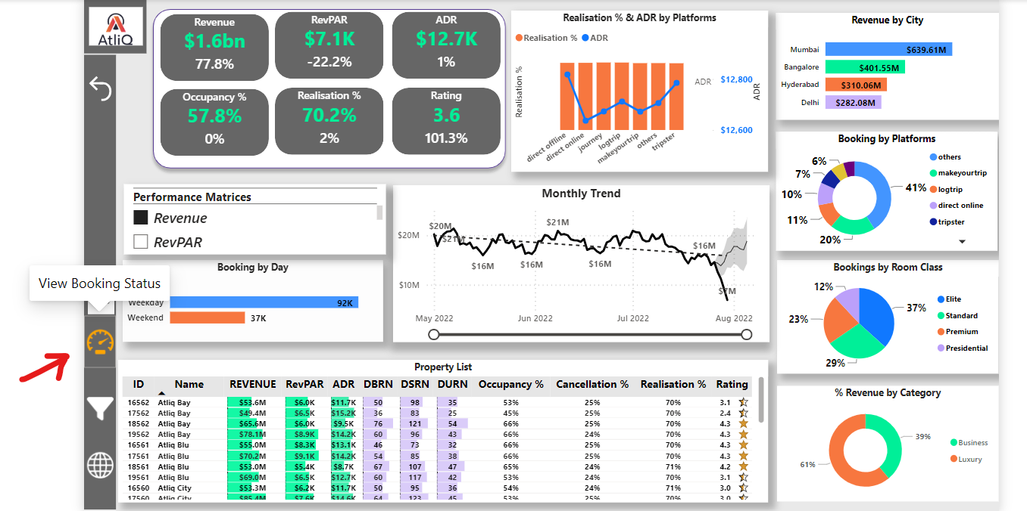

We get the below view.

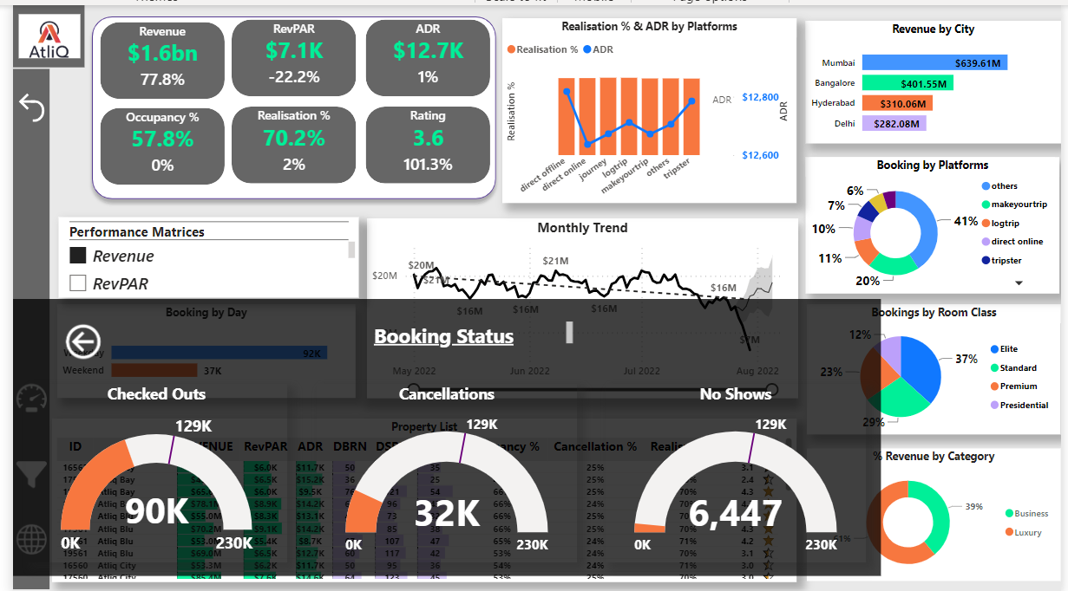

**Filter Selection View**

By clicking the ‘*View Booking Status’* button

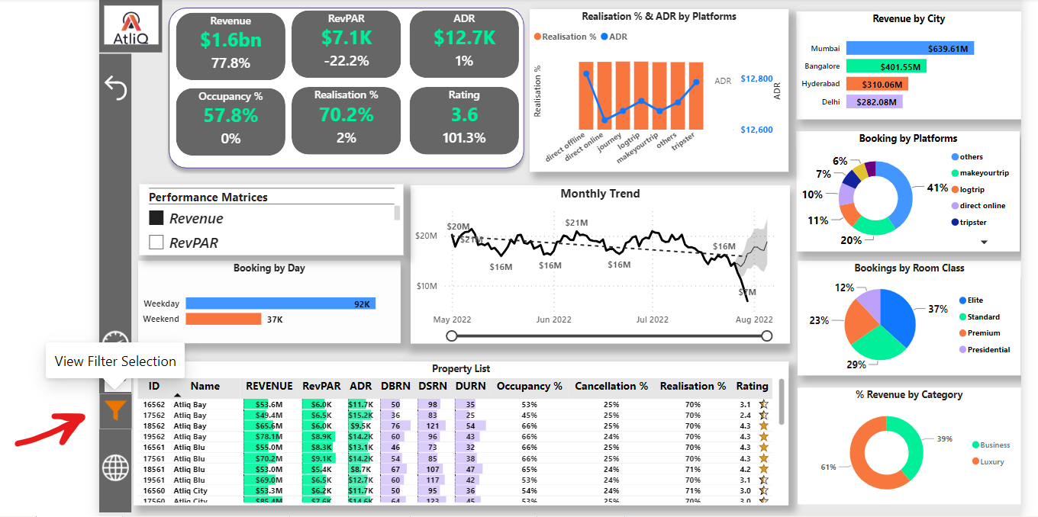

We get the below view

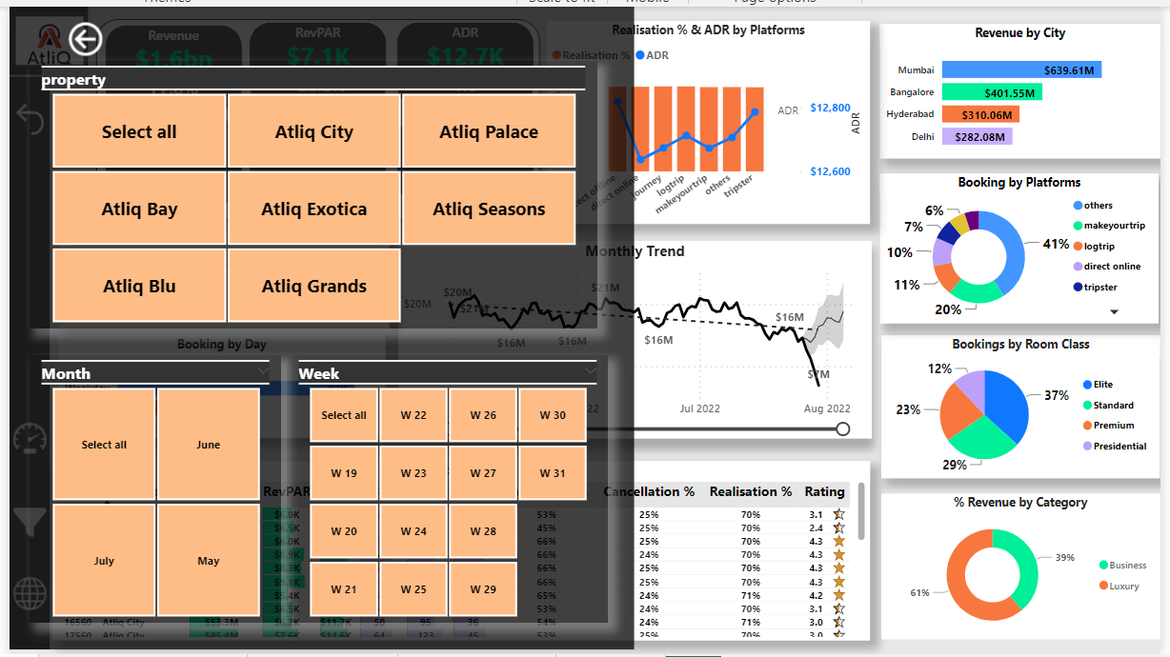

Here we can select desired filters for the dashboard.

**Map View**

By clicking the ‘*View Booking Status’* button

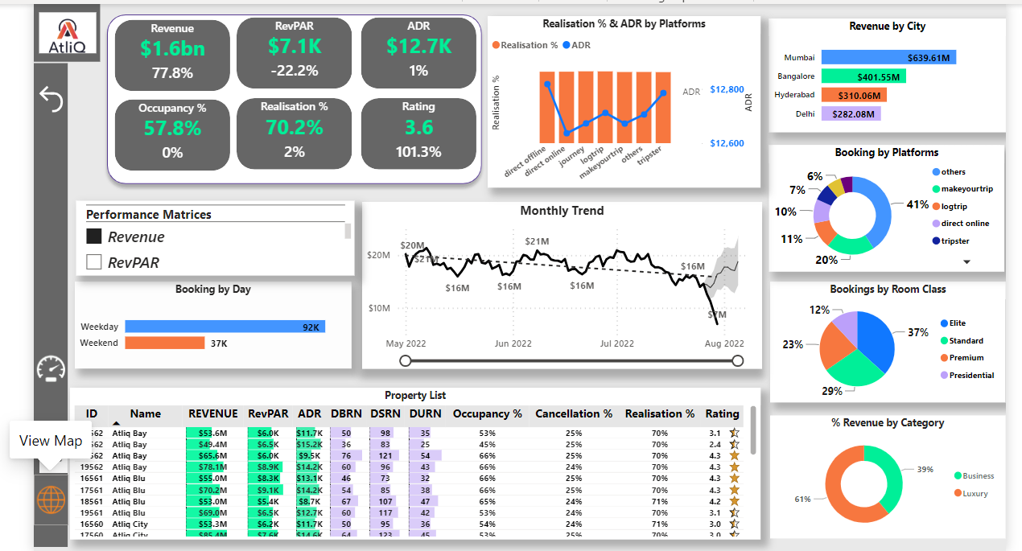

We get the below view

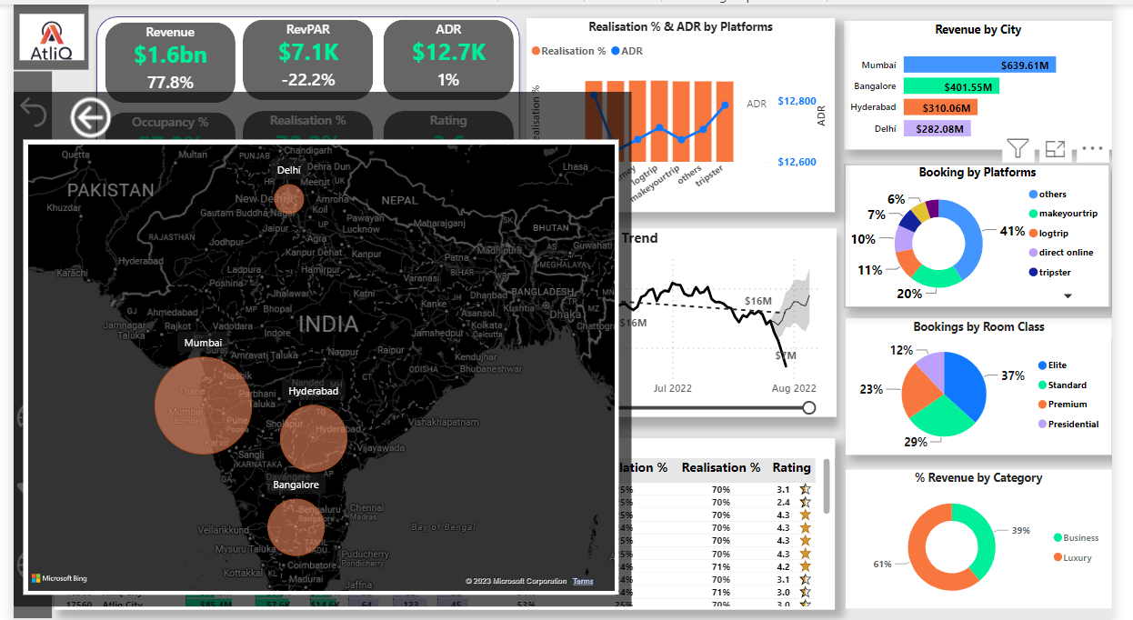

When we hover over a geographical location bubble in the map we get the below view-

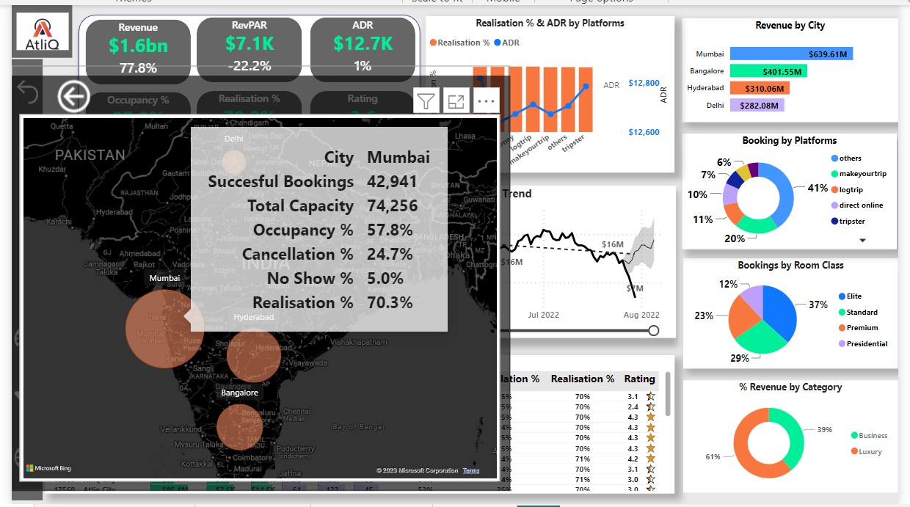

**Tooltip Views-**

By hovering over the ’Revenue by City’ visual, the below tooltip view gets shown-

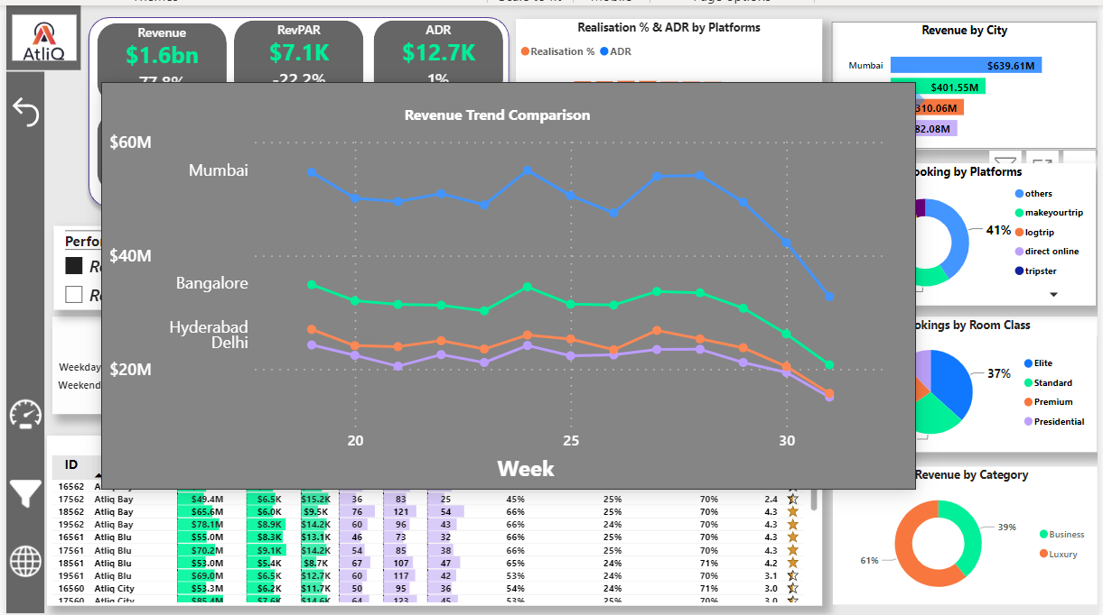

By hovering over the % Revenue by Category’ visual, the below tooltip view is shown -

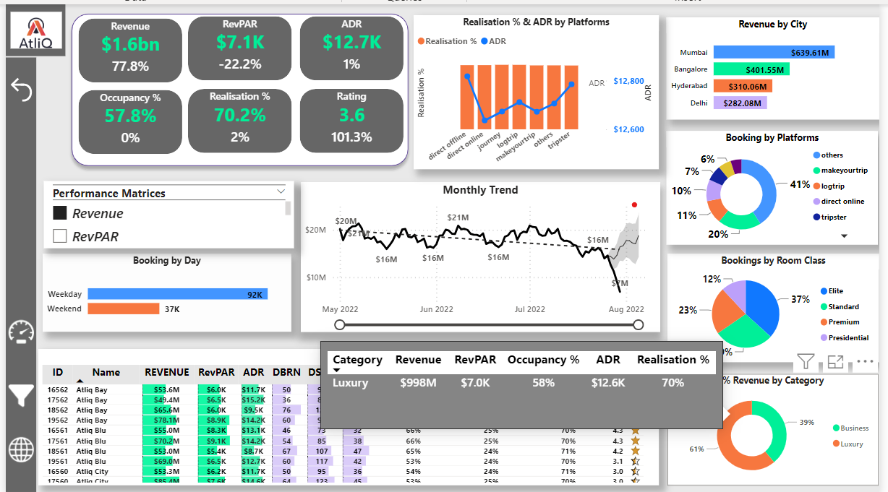

By hovering over the ‘Bookings by day’ visual, the below tooltip view gets shown -

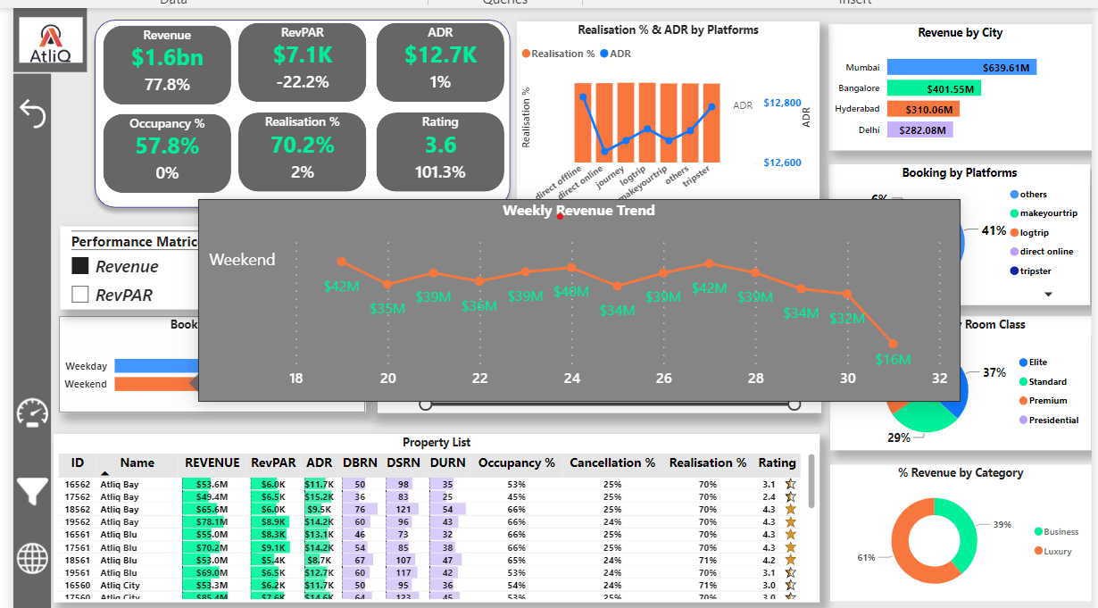

**We can get different trend line graphs by choosing different performance matrices-**

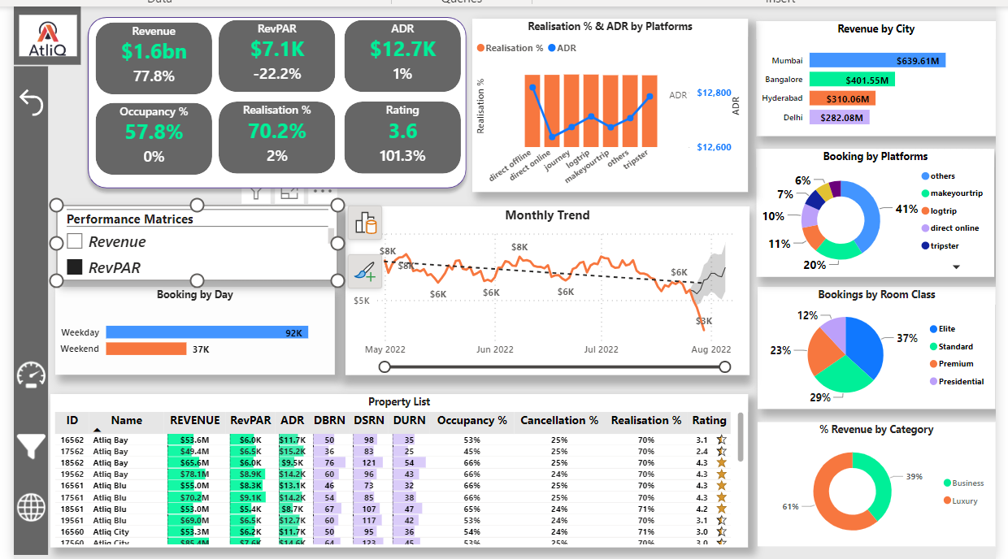

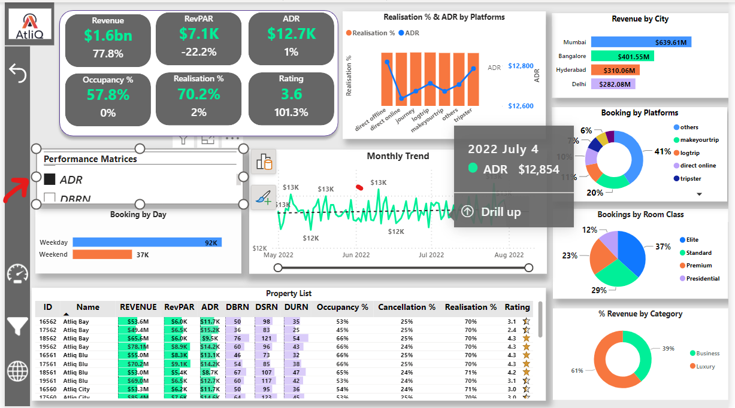

To reset the filtered view of the dashboard to the unfiltered/home view, we have the reset but-

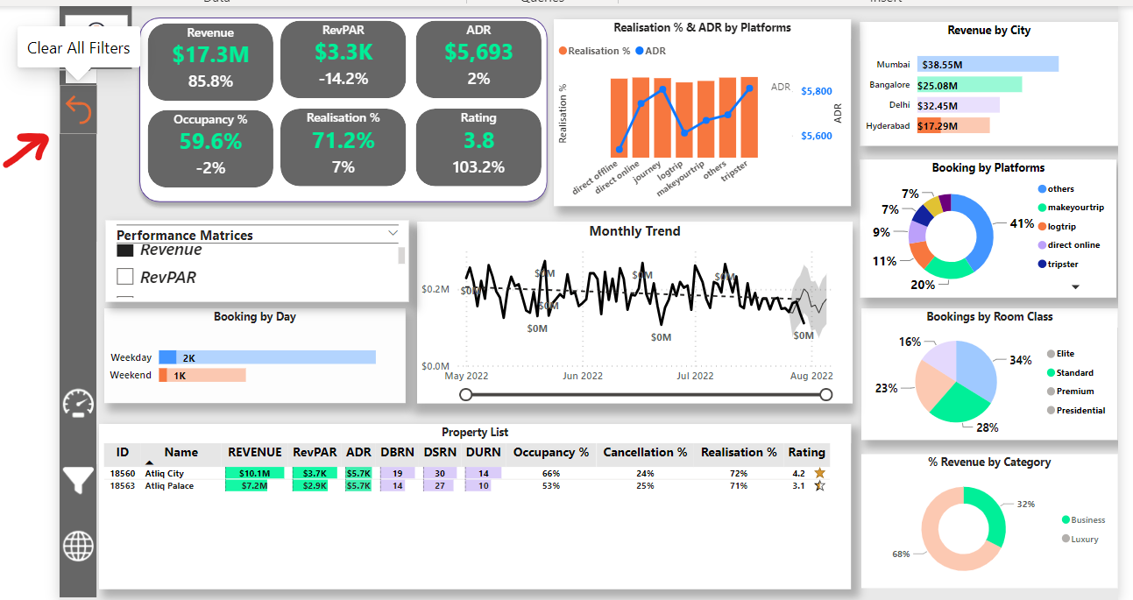

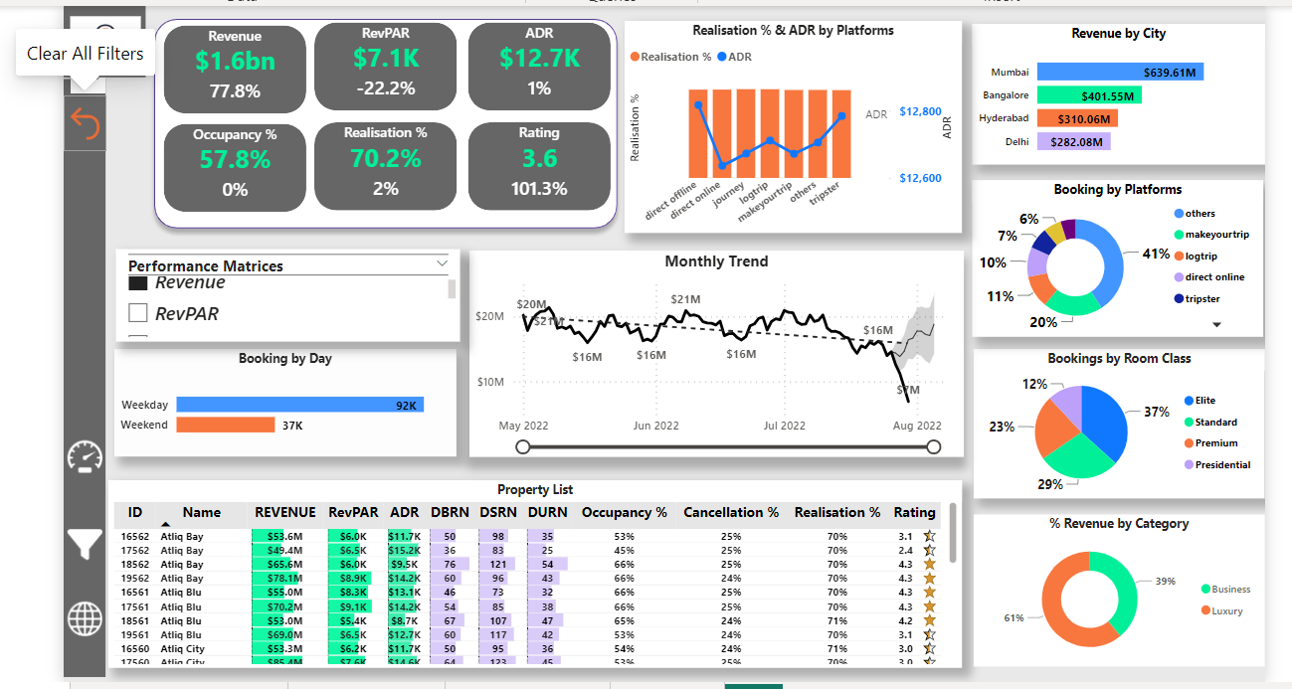

**Derived Key Insights:**

Ø Occupancy rate is higher on weekends (Friday, Saturday) than on weekdays, hence revenue also follows the same trend. There is potential growth in revenue by introducing a week-dynamic pricing strategy.

Ø DSRN has been constant for the recent 3 months of period, which means there were zero rooms at maintenance.

Ø In the last 3 months overall Revenue (performance) trend going down.

Ø Least rated hotels are,

Atliq Seasons, Mumbai (rating = 2.3)

Atliq Exotica, Hyderabad (rating = 2.3)

Atliq Grands, Bangalore (rating = 2.3)

Atliq Bay, Mumbai (rating = 2.4)

Which means, there is something wrong with the quality of services they provide.

Ø AtliQ Palace, Hyderabad is one of the highest ratings (rating: 4.3) hotels, still, it belongs to the group of highest cancellations (cancellations: 26%).

Ø AtliQ Grands, Delhi is one of the highest-rated hotels in the luxury category, still generating the least revenue compared to others in the same category, but there is some potential to perform better.

Ø ‘Journey’, ‘Tripster’ & and ’Direct offline’ are the bottom 3 channels in terms of capture bookings.

Ø Almost 60 % of revenue is generated by luxury category hotels. In the luxury category approximately 50% of hotels have poor ratings (that is below 3) and the lowest occupancy rate as well. So, there is an opportunity for betterment and to achieve potential market share.

Ø The weekly trend of the ADR and Occupancy % is almost parallel which indicates that a dynamic pricing strategy is not incorporated, it would give positive results if incorporated.

Ø Bangalore is 2nd highest revenue generated city, but out of six, four hotels are underperforming in terms of occupancy and customer rating. There is a gap between market size and quality supply.

-------------------------------------------------------------------------------------------------------------